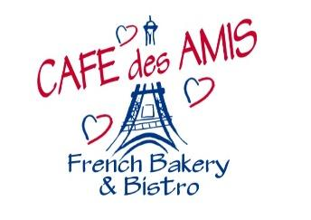

CHRISTMAS ORDER FORM

Ham: $6.50 lb _______

Quiches: $30 Donuts:

Lorraine (bacon & swiss) _____ Assorted Easter Donuts:
Goat Cheese & Leek _____ __ ½ Dozen $9 __ 1 Dozen $17
Ham & Cheddar _____ Icing: __Red __Green
Spinach & Mushroom _____ __ Chocolate __Vanilla
Christmas Quiche _____ Toppings: __ Rudolf __ Snowman
__ Snowflake __ Christmas Sprinkle
*Choose cut: __ 6’s __ 8’s __ 12’s __ none __ Chocolate Kisses __ Cinnamon/Sugar
Custom Toppings:____________________
__________________________________
Side Dishes: 16oz $6.45 32oz $11.95 Desserts:

16 oz 32 oz Brownie $1.95 _____
Streusel Sweet Potatoes _____ _____ Chocolate Mousse $3 _____
Fresh Fruit Salad _____ _____ Bread Pudding $5.50 _____
Cucumber Salad _____ _____ Macarons Dozen Assorted $12 _____
Baked Apples _____ _____
Mashed Potatoe _____ _____
Roasted Red Potatoes _____ _____
Macaroni & Cheese _____ _____

Pies: 5” Deep Dish $5.50 10” $10.00 Breads:
5” 10”
Apple _____ _____ Mancini 12” stick $2.00 _____
Cherry _____ _____ Mancini Rolls Dz $6 _____
Peach _____ _____
Blueberry _____ _____
Pecan _____ _____
Pumpkin _____ _____

PICK UP DAY: _______________________________________________________

Place your order by calling 412-741-2388 or email bonjour@cafedesamissewickley.com

